Lesson 175 & 176

Introducing Reflogs

They are logs

I will now change the branch now

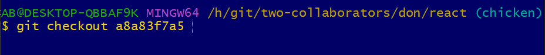

It does not work on my machine but

Lesson 177

Limitation of Reflogs

Lesson 178

The Git Reflog Show Command

<https://git-scm.com/docs/git-reflog>

Git reflog show HEAD

Lesson 179

Passing Reflog References

This is the last 10 moves since the beginning of the repo



This is like 2 moves ago.



Lesson 180

Time-Based Reflog Qualifiers

Remember it only include local changes and it does not go back more 90 days.







This take you to detach head from here you can also run git log –oneline.

Lesson 181

Rescuing Lost Commits With Reflog

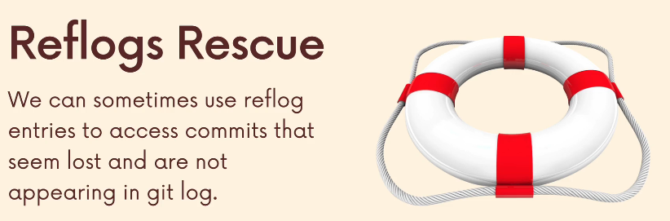

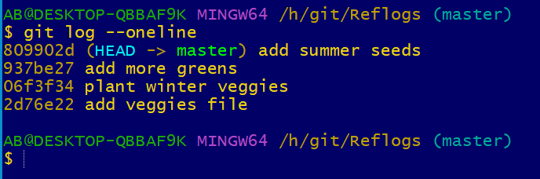

I want the changes back

Now I want to undo that I deleted it

It has successfully restore it back once the number is put back it will restore it.

Lesson 182

Undoing A Rebase w/ Reflog- it’s Miracle!

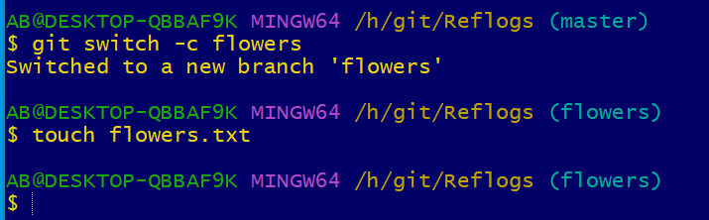

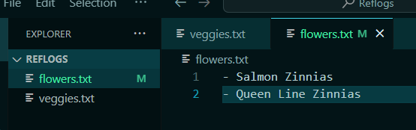

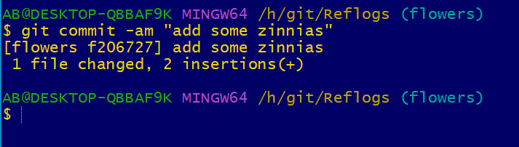

I want to merge them into master but before I do that I want to rebase. I will do an interactive rebase to get rid of some of this commit

It will discarde the log message.

Close the window

Old history

New history

Closed

If I realised that was a big mistake I need to go back again

This is the log history

It has reset the history back

It restore the history